No wrestling sport.

HOME Page copy -

Got it. I’d keep the stronger community, friendships, camaraderie, and giving-back message, and save space by making the sports section a clean visual selector instead of explaining each sport on the homepage.

Become a Sports Official in Southwest Florida

Stay involved. Give back. Join the crew.
Officiating is a way to stay connected to the sports you love, meet great people, stay active, earn some extra money, and give back to the athletes, schools, and families in your community.
Maybe you played.
Maybe you coached.
Maybe your kids played.
Or maybe you’ve simply loved sports your whole life.
Whatever brought you to the game, officiating gives you another way to be part of it.
Greater Naples Officials Association recruits, trains, and supports new and experienced officials throughout Naples, Collier County, and Southwest Florida.
[Become an Official]
[Experienced Official? Connect With GNOA]

There’s Still a Place for You in the Game
You don’t have to be playing or coaching to stay involved in sports.
Officials are an important part of what makes local games possible.
You get a different view of the game, a new challenge, and a chance to become part of a community of people who enjoy sports just as much as you do.

Stay Connected
Keep participating in the sports that have been part of your life.

Join a Great Group of People
Work alongside officials from different backgrounds who share a love of sports and enjoy being part of a crew.

Stay Active
Officiating keeps you moving, thinking, and engaged.

Make Some Extra Money
Work games around your availability and earn additional income doing something you enjoy.

Give Back
Help local athletes, schools, leagues, and families continue playing the games they work hard to prepare for.

Find Your Sport
Start with the sport you know, the sport you played or coached, or simply the one you enjoy most.

Football
[Explore Football]

Basketball
[Explore Basketball]

Baseball
[Explore Baseball]

Softball
[Explore Softball]

Soccer
[Explore Soccer]

Volleyball
[Explore Volleyball]

Wrestling
[Explore Wrestling]

Never Officiated Before?

That’s what training is for.
You don’t need previous officiating experience to get started.
Nobody expects you to know every rule, signal, position, or mechanic on day one.
GNOA helps new officials learn what they need to know and connects them with experienced officials who remember exactly what it felt like to work their first game.
You’ll learn the rules.
You’ll learn where to be.
You’ll learn how to communicate.
And most importantly, you’ll learn by doing.
[Learn How to Get Started]

You Become Part of a Community
One of the best parts of officiating is the people you meet.
You’ll work games with people from different professions, different ages, and different backgrounds, all connected by the same thing:
They enjoy sports.
You’ll prepare together.
Work games together.
Talk about plays afterward.
Help newer officials.
Learn from experienced officials.
And probably share plenty of laughs along the way.
For many officials, the friendships and camaraderie become just as important as the games.

Local Sports Need Officials
Games don’t happen without people willing to officiate them.
Athletes prepare.
Coaches prepare.
Schools and families show up.
But somebody still has to step onto the field, court, or mat and help make the competition possible.
Officiating is a practical way to give something back to your community.
You’re helping local athletes compete.
You’re helping schools and programs play their schedules.
And you’re helping make sure the next generation gets the same opportunity to enjoy sports that you did.
That matters.

Can I Officiate Part-Time?
Absolutely.
Officiating is flexible, and you can block off dates when you’re unavailable and work around your schedule.
Games are typically played on weekday evenings and Saturdays, with no Sunday games.
For many officials, it fits alongside work, family, travel, and other commitments.

Training & Support
Good officials aren’t expected to figure everything out on their own.
GNOA provides pre-season and in-season training opportunities for each sport to help officials prepare, review rules and mechanics, ask questions, and continue learning throughout the season.
Development isn’t only about moving to a higher level.
Sometimes getting better means communicating more clearly, being in a better position, handling a difficult situation better, helping a newer official, or simply becoming more comfortable and confident in your role.
[View Training Information]

Already an Experienced Official?

Come join the crew in Southwest Florida.
If you’re relocating to Naples, Collier County, or the surrounding area, or simply looking for a new association, we’d like to hear from you.
Tell us which sport you officiate and a little about your experience.
We’ll connect you with the appropriate GNOA leadership and help you understand the local process.
More than anything, we’re looking for good people who enjoy sports and want to be part of the officiating community.
[Connect With GNOA]

What Will I Need?
Every sport has its own uniform and equipment requirements, but don’t rush out and buy everything before talking with GNOA.
We’ll help you understand what you actually need and what can wait.
Experienced officials may also have used, extra, or hand-me-down equipment available for someone just getting started.

Talk to us first. See what’s available. Buy what you need.

Ready to See the Game From This Side?
Maybe you miss being around sports.
Maybe you want to stay active.
Maybe you’re looking for a way to make a little extra money.
Maybe you want to give something back.
Or maybe you’d simply enjoy spending time with a good group of people who love sports too.
There’s room for you here.

Stay involved. Give back. Join the crew.
[Become an Official]
[Choose Your Sport]
Greater Naples Officials Association
Naples · Collier County · Southwest Florida
Football · Basketball · Baseball · Softball · Soccer · Volleyball · Wrestling
For the actual design, I’d make those seven sport names seven image tiles/cards. That gives each sport equal visibility without using a big block of homepage copy explaining things that are already covered on the individual sport pages.

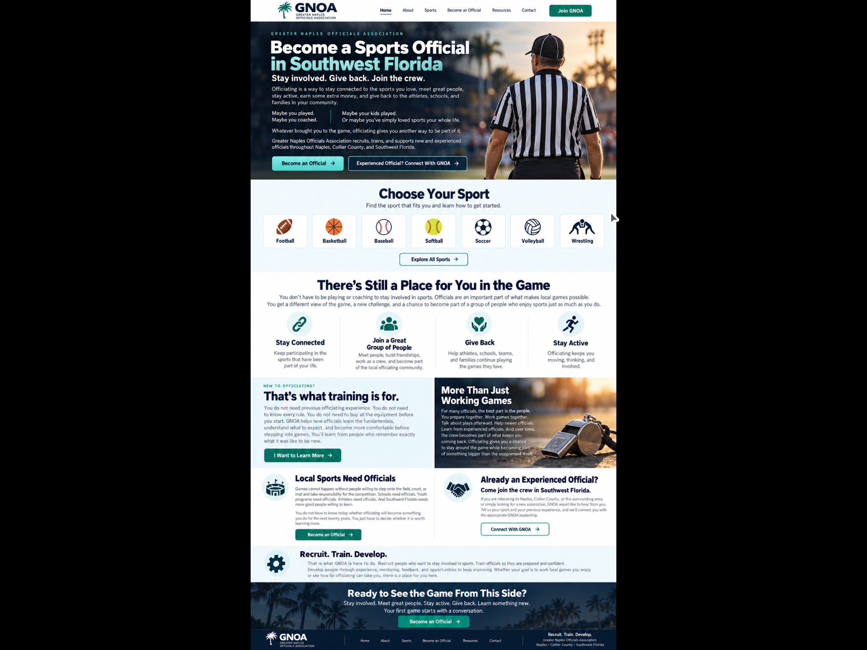

Become a Basketball Official in Southwest Florida

Stay in the game. Be part of the community.

Basketball officiating is a way to stay connected to a game you enjoy while giving something back to the athletes, schools, and families in your community.

You’ll stay active, learn the craft of officiating, and become part of a group of people who enjoy basketball and enjoy working together.

Greater Naples Officials Association recruits, trains, and supports new and experienced basketball officials throughout Naples, Collier County, and Southwest Florida.

[Become a Basketball Official]

[Experienced Official? Connect With GNOA]

A Different Way to Be Part of Basketball

You don’t have to play or coach to stay involved in the game.

Officials are a big part of what makes local basketball possible.

Every game needs people who are willing to show up, make decisions, work together, and help create a fair environment for athletes to compete.

Stay Connected to the Game

If basketball has been part of your life, officiating gives you a new way to enjoy it.

Give Back to Your Community

Help local athletes, schools, and programs play the games they’ve worked hard to prepare for.

Join a Great Group of People

Work alongside other officials who enjoy basketball, enjoy the camaraderie, and understand what it’s like to be on the floor.

Stay Active

Basketball keeps you moving and mentally engaged from the opening tip to the final horn.

Never Officiated Before?

That’s what training is for.

You don’t need previous officiating experience to get started.

GNOA helps new basketball officials learn the fundamentals, understand what to expect, and become more comfortable on the court.

You’ll learn:

Basketball rules and responsibilities

Court positioning and coverage

Signals and mechanics

Fouls and violations

Crew communication

Game management

Working with players and coaches

How to learn from each game

Nobody expects you to know everything on day one.

You’ll have other officials around you who remember exactly what it was like to work their first game.

[I Want to Learn More]

How Do I Get Started?

Tell Us You’re Interested

Complete the short form and select Basketball.

Meet the Basketball Team

We’ll explain the season, training, registration, equipment, and what officiating is really like.

Learn the Fundamentals

Study the rules, practice mechanics and positioning, and learn how officials work together as a crew.

Work Your First Games

Start with assignments that fit your training and experience.

Keep Learning

Every game gives you another chance to become more comfortable and confident.

[Start the Process]

What Makes a Good Basketball Official?

Positioning

Being in the right place helps you see the play clearly and make better decisions.

Judgment

Not every bit of contact is a foul.

Experience helps you recognize what happened, what mattered, and when the game needs a whistle.

Communication

Officials communicate constantly with their partners, players, coaches, and game administrators.

Teamwork

You’re not out there by yourself.

A good crew communicates, supports one another, and works together throughout the game.

Composure

Basketball can get emotional.

Good officials stay calm, professional, and focused on the next play.

You Become Part of a Crew

One of the best parts of officiating is the people you meet.

You’ll work games with people from different backgrounds and different stages of life, all connected by the same thing:

They enjoy the game.

You’ll prepare together.

Work games together.

Talk about plays afterward.

Help newer officials.

Learn from experienced officials.

And probably share a few laughs about things that happened during the night.

For many officials, the friendships and camaraderie become as important as the games themselves.

The Game Starts to Slow Down

Your first few games may feel fast.

That’s normal.

At first, you may feel like you’re trying to watch everything at once.

With training and experience, you learn where to look, where to move, what belongs to you, and when to trust your partners.

The game doesn’t actually get slower.

You get better at seeing it.

Giving Back to Local Basketball

Games don’t happen without officials.

Youth players, high school athletes, coaches, families, and schools all depend on people willing to step onto the court and take responsibility for the game.

Officiating is a practical way to contribute to the sports community.

You’re helping create opportunities for athletes to compete.

You’re helping schools and programs play their schedules.

And you’re helping make sure there are officials for the next generation of basketball players.

That matters.

Already an Experienced Basketball Official?

Come join the crew in Southwest Florida.

If you’re relocating to Naples or the surrounding area, or simply looking for a local association, we’d like to hear from you.

Tell us about your previous officiating experience, and we’ll connect you with GNOA basketball leadership.

More than anything, we’re looking for good people who enjoy the game and want to be part of the local officiating community.

[Connect With GNOA Basketball]

Keep Getting Better

Development is part of officiating, but it doesn’t have to mean chasing the next level.

Sometimes getting better simply means:

Being in a better position.

Communicating more clearly.

Handling a difficult situation better than you did last time.

Helping a newer official.

Becoming a partner other officials enjoy working with.

Feeling more confident on the floor.

There is always something to learn, no matter how many games you’ve worked.

Rules Study · Mechanics · Crew Work · Mentoring · Feedback · Experience

What Will I Need?

Basketball requires an approved officiating uniform and some basic equipment, but don’t start buying everything before talking with GNOA.

We’ll help you understand what you actually need and what can wait.

Experienced officials may also have extra, used, or hand-me-down items available for someone just getting started.

Talk to us first. See what’s available. Buy what you need.

Basketball Officiating FAQs

Do I need previous officiating experience?

No. GNOA helps new officials learn how to get started.

Do I need to have played basketball?

No. Playing or coaching experience can help with familiarity, but officiating is its own skill.

Do I need to know every rule before my first game?

No. You need a foundation, but rules knowledge and judgment continue developing through training and experience.

Is basketball officiating physically demanding?

It’s an active sport. Officials move throughout the game and need to maintain good positioning on the court.

Will I be working by myself?

No. Basketball officials work as a crew. Learning to trust and communicate with your partners is an important part of officiating.

What if I’m mainly interested in giving back and working local games?

That’s a great reason to officiate. You don’t have to have ambitions of moving to higher levels. Local basketball needs good officials who enjoy being part of the game and the community.

Should I buy a uniform now?

Talk with GNOA first. We can explain what you need and whether used or hand-me-down equipment may be available.

Ready to See Basketball From This Side?

Maybe you miss being around the game.

Maybe you’re looking for a way to give something back.

Maybe you want to stay active.

Or maybe you’d simply enjoy spending time with a good group of people who love basketball too.

There’s room for you here.

Stay in the game. Give back. Join the crew.

[Become a Basketball Official]

Greater Naples Officials Association
Naples · Collier County · Southwest Florida

GNOA Volleyball Page — Image Replacement Instructions (I was able to add them in there, so this may not be needed)
I am providing a ZIP file named GNOA-Volleyball-Images.zip containing the approved images for the GNOA Volleyball page. -
Please update the Become a Volleyball Official in Southwest Florida page using these images.

Important
Do not redesign the page.
Do not change:
- Page copy
- Headlines
- Buttons
- Colors
- Fonts
- Cards
- Section order
- Overall spacing or layout unless necessary to display an image correctly
This task is specifically to replace the existing/current placeholder images with the supplied volleyball images.

Do not modify the supplied images
Do not:
- AI regenerate them
- Enhance or restyle them
- Remove or add people
- Change uniforms
- Change backgrounds
- Add text
- Add or remove logos
- Apply filters
Use the files exactly as supplied.
Normal responsive cropping with CSS such as object-fit: cover and focal-point positioning is fine when necessary.

Image Placement
The filenames identify where each image belongs.

Hero — Become a Volleyball Official in Southwest Florida
Use:
Become-a-volleyball-official-in-SW-Florida.jpeg
Place this as the primary image for the hero section containing:
Become a Volleyball Official in Southwest Florida
and:
Stay in the game. See every rally differently.

Never Officiated Before?
Use:
Never-officiated-before.jpeg
Place this in the:
Never Officiated Before?
That’s what training is for.
section.
This should support the new-official/training message.

The Match Starts to Look Different
Use:
The-match-starts-to-look-different.jpeg
Place this with the section:
The Match Starts to Look Different
This image should support the message about officials becoming more comfortable seeing rotations, positioning, the net, players, their partner, and the overall match as they gain experience.

Already an Experienced Volleyball Official?
Use:
Already-an-experienced-volleyball-official.jpeg
Place this image in the:
Already an Experienced Volleyball Official?
section.
This is the section inviting experienced officials who are relocating to Southwest Florida or looking for a new association to connect with GNOA.

Keep Developing / Advancement
Use the following three images to visually show the progression of a volleyball official.

Varsity
Use:
Varsity.jpeg
Place this with the development content representing officials progressing into varsity-level assignments.

Postseason
Use:
Postseason.jpeg
Place this with the development content representing postseason opportunities.

Championship
Use:
Championship.jpeg
Place this with the development/recognition content representing championship-level assignments.
These three images should appear in this order:
Varsity → Postseason → Championship
They should visually support the Keep Developing section and the idea that officials may progress toward:
Varsity · Postseason · Championship Assignments
Do not imply that every official has to pursue advancement. The page should continue communicating that officials who simply want to stay involved and work games they enjoy are equally welcome.

What Will I Need?
Use:
What-will-I-need.jpeg
Place this with the section:
What Will I Need?
This should accompany the information about volleyball uniforms and basic officiating equipment.
Use this specific image rather than any earlier image that may have been considered for this section.

Final CTA — Ready to See Volleyball From This Side?
Use:
Ready-to-see-volleyball-from-this-side.jpeg
Place this in the final recruiting CTA section containing:
Ready to See Volleyball From This Side?
and the final:
Become a Volleyball Official
CTA.
This should be the final major photograph before the footer.

Image Order Summary
The supplied volleyball images should map to the page as follows:
Become-a-volleyball-official-in-SW-Florida.jpeg
→ Hero
Never-officiated-before.jpeg
→ Never Officiated Before / Training
The-match-starts-to-look-different.jpeg
→ The Match Starts to Look Different
Already-an-experienced-volleyball-official.jpeg
→ Experienced Volleyball Official
Varsity.jpeg
→ Varsity development
Postseason.jpeg
→ Postseason development
Championship.jpeg
→ Championship development / recognition
What-will-I-need.jpeg
→ Equipment / What Will I Need?
Ready-to-see-volleyball-from-this-side.jpeg
→ Final CTA

Implementation Requirements
Please preserve the existing responsive behavior of the website.
For each image:
- Maintain the original proportions whenever practical.
- Do not stretch or distort the image.
- Use object-fit: cover if the existing design uses fixed image containers.
- Adjust object-position when necessary to keep the official as the primary subject.
- Do not unnecessarily crop faces or the main official out of the image.
- Keep image treatment consistent with the other GNOA sport pages.
- Use responsive image sizing.
- Optimize file size for web performance if necessary without visibly degrading the image.
- Do not bake page copy into the images.
Add useful alt text based on what the image communicates rather than simply copying the filename.
Examples:
Hero:
GNOA volleyball officials in Southwest Florida
Never Officiated Before:
Volleyball official working a match as part of GNOA
Experienced Official:
Experienced GNOA volleyball officiating crew
Varsity:
Volleyball official working a varsity match
Postseason:
GNOA volleyball official working a postseason assignment
Championship:
Volleyball officials selected for a championship assignment
What Will I Need:
Volleyball official with basic officiating equipment

Final QA
After replacing the images, please check the Volleyball page on:
- Desktop
- Tablet
- Mobile
Confirm that:
- All 9 supplied volleyball images are being used.
- Every image appears in its intended section.
- No image has accidentally been duplicated.
- No old placeholder image remains in one of these designated locations.
- Images are not stretched or distorted.
- Faces and officials are not unnecessarily cropped.
- The page copy remains unchanged.
- The page design remains unchanged.
- Buttons and links still work.
- No other sport pages were modified.
Do not make unrelated improvements while performing this task.
Once complete, provide the updated Volleyball page URL or preview so I can visually review all image placements before any additional changes are made.

GNOA Baseball Page — Image Replacement Instructions
I am providing a ZIP file named GNOA-Baseball-Images.zip containing the approved images for the GNOA Baseball page.
Please update the Baseball — Become a Baseball Umpire in Southwest Florida page using these images.

Important
Do not redesign the page.
Do not change:
- Page copy
- Headlines
- Buttons
- Colors
- Fonts
- Cards
- Section order
- Spacing/layout unless necessary to properly display an image
This task is specifically to replace the existing placeholder/current images with the supplied images.

Do not modify the supplied images
Do not:
- AI regenerate them
- Enhance or restyle them
- Remove people
- Add people
- Change uniforms
- Change backgrounds
- Add text
- Add logos
- Remove logos
- Apply filters
Use the files exactly as supplied.
You may use normal responsive cropping with CSS (object-fit: cover, positioning, etc.) when necessary to fit the existing design.

Image Placement
The filenames identify where each image belongs.

Hero — Become a Baseball Umpire in Southwest Florida
Use:
Become-a-baseball-umpire-in-SW-Florida.jpeg
Place this as the primary hero image for the baseball page.

Never Umpired Before?
Use:
Never-umpired-before.jpeg
Place this in the Never Umpired Before? / That’s what training is for section.

What Does a Baseball Umpire Learn?
Use the following images with their corresponding cards/content.

Positioning
Positioning.jpeg

Plate Work
Plate-work.jpeg

Base Mechanics
Base-mechanics.jpeg

Rules
Rules.jpeg

Judgment
Judgement.jpeg
Note: Keep the supplied filename spelling as-is.

Communication
Communication.jpeg

Timing Matters / Your First Game Is Just the Beginning
Use:
Timing-matters-your-first-game-is-the-beginning.jpeg
Use this image for the section covering Timing Matters and/or Your First Game Is Just the Beginning, following the existing page design.

Already an Experienced Baseball Umpire?
Use:
Already-an-experienced-umpire.jpeg
Place this image in the experienced umpire section.

From Your First Game to Your Biggest Assignment
Use the following images for the four development stages.

New Umpire Training
New-umpire-training.jpeg

Working Local Baseball
Working-local-baseball.jpeg

Postseason Opportunities
Postseason-opportunities.jpeg

Recognition and Championships
Recognition-and-championship.jpeg
These should appear in this order:
New Umpire Training → Working Local Baseball → Postseason Opportunities → Recognition and Championships

What Will I Need?
Use:
What-will-I-need.jpeg
Place this with the baseball equipment / What Will I Need? section.

Final CTA — See Baseball From the Best Seat in the Park
Use:
See-baseball-from-the-best-seat-in-the-park.jpeg
Place this in the final recruiting CTA section near:
See Baseball From the Best Seat in the Park
and the final Become a Baseball Umpire button.

Implementation Requirements
Please preserve the existing responsive behavior of the site.
For images:
- Maintain their natural proportions whenever practical.
- Do not stretch or distort them.
- Use object-fit: cover where a fixed image container requires cropping.
- Prioritize keeping the umpire/official visible when selecting the focal point.
- Use appropriate responsive image sizing.
- Do not bake page text into the images.
- Add descriptive alt text based on the section rather than simply repeating the filename.
Examples:
- Positioning image: Baseball umpire positioned for a play on the bases
- Plate Work: Baseball umpire working behind home plate
- New Umpire Training: New baseball umpires participating in training
- Postseason Opportunities: Experienced baseball umpire crew
Compress/optimize images for the web if appropriate, but do not visibly alter image quality or content.

Final QA
After replacing the images, please check the Baseball page on:
- Desktop
- Tablet
- Mobile
Confirm:
- All 16 supplied images are being used.
- Each image is in the correct section.
- No image is accidentally duplicated.
- No old placeholder images remain in these designated locations.
- Images are not stretched or distorted.
- Faces and officials are not unnecessarily cropped out.
- Page copy and design remain unchanged.
- Buttons and links still work.
- No other sport pages were changed.
Once complete, provide me with the updated Baseball page URL or preview so I can visually review all image placements before anything else is changed.

Sports pictures - https://gnoa.bryan-594.workers.dev/sports/
- sports cover images .zip. - in drive

Recruit train develop pic - https://gnoa.bryan-594.workers.dev/training-development/

